Application Data Sheet
AIMCO Manufacturing | [Phone] 419-478-4851 | [Fax] 419-476-1324
203 Matzinger Rd. Toledo, OH 43612
Use our online form as an alternative to this word document by clicking the link:
http://www.aimcomanufacturing.com/rfq.html

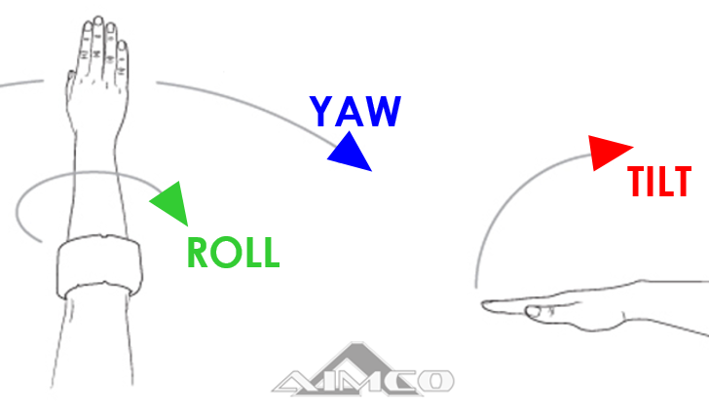
Contact Information
Filled Out By: |  | First and Last Name
Company Name: |  | Inc. | Corp.
Customer Type: |  | Distributor | End User

Part Specifications
P1 | Part Weight Range | ____ lbs. – ____ lbs.
P2 | Number of Different Parts | ____
P3 | Part Dimension Range | X” - X” (left-to -right) x Y” - Y” front-to-back x Z” - Z” top-to-bottom  Ø” – Ø” (OD) if applicable x Ø” – Ø” (ID) if applicable
P4 | Grab Surface(s) | Top Face or Front Face or Bottom Face or Left & Right Sides
P5 | Part Material | Solid Surface or Porous or Perforated or Ferromagnetic
P6 | Part Orientation at Pick  (if or, pick one) | - Horizontal & Long-ways Left-to-Right or Long-ways Front-to-Back  - Vertical & Long-ways Top-to-Bottom or Long-ways Left-to-Right  - Eye-to-Sky or Eye-to-Side
P7 | Part Orientation at Place  (if or, pick one) | - Same as Pick Point, straight Pick & Place only  - Horizontal & Long-ways Left-to-Right or Long-ways Front-to-Back  - Vertical & Long-ways Top-to-Bottom or Long-ways Left-to-Right  - Horizontal & Flipped 180  - Vertical & Flipped 180  - Eye-to-Sky or Eye-to-Side

Crane
C1 | Crane Type | AIMCO Articulating Jib XX ft (Reach) x XX ft (Height) or Bridge Crane (By Other)
C2 | Crane Obstructions | Describe: (i.e. Building Ceiling/Header, Power Lines, or Light Fixtures)

Lifting
L1 | Lifting Mechanism | AIMCO TorqLIFT or Air Hoist or Air Balancer or Hoist (By Other) or G-Force (By Other)
L2 | Vertical Travel | XX” from minimum to maximum height (referenced from bottom of part)

Tooling
T1 | Tooling Type | Gripper| Vacuum | Magnet | Forks/Hooks | Other:
T2 | Tooling Reach-Out | XX” reaching under/over an obstruction
T3 | Tooling Approach into Part | Towards Front or From Top Down or From Bottom Up

Notes/Sketches/Special Considerations/Process & Work-cell Descriptions
[Notes]

www.AimcoManufacturing.com |Sales@AimcoManufacturing.com

